Proposed changes to the Thermal Regime in the North Santiam Subbasin

ODFW has proposed changes in operation of Detroit and Big Cliff dams to alter the temperature regime experienced by anadromous fish below the projects. The most substantial proposed change is for operations in July through September where current temperature targets (54 – 60+ degrees F) would decrease to 48 – 54 degrees F). Additional decreases in temperature targets in October (50 degrees F reduced to 48 degrees F) and November (50 degrees F reduced to 44 degrees F) were also proposed.

The changes in thermal regime were hypothesized to provide benefits for fish and fisheries in the North Santiam subbasin. Reduced temperatures in July through September are expected to increase survival for fish holding in the river and for fish being held at the Minto Fish Collection Facility. Also, reduced temperatures over that period may also increase harvest efficiency for summer-run steelhead, decreasing the potential for negative interactions between the hatchery-origin summer-run and the native winter-run. The reduced temperature targets in October and November are expected to further compress the difference between emergence timing of Chinook salmon above and below the projects, reducing the negative effects of early emergence for fish produced below the projects.

ODFW is reasonably confident that the proposed changes to the thermal regime will confer the theoretical benefits described above. ODFW does not know if the changes, especially the large, protracted changes in July through September, are possible. Therefore, ODFW requests discussion on the following topics:

1. Are there technical constraints on achieving the temperature changes proposed for July through September? October through November?
2. What might be the biological benefits of the proposed changes to fish being held on station at Minto? Would there likely be benefits realized from changes of smaller magnitude and/or shorter duration?
3. What might be the biological benefits of the proposed changes to fish holding and spawning in the river below Big Cliff and Minto dams? Would there likely be benefits realized from changes of smaller magnitude and/or shorter duration?
4. How substantial might be the increase in harvest rate of hatchery-origin fish and what might be the benefits of decreased pHOS in the lower subbasin?
5. How closely would emergence timing below the projects converge with emergence timing above Detroit Dam if the proposed temperature targets are achieved?

|  |  |  |  |  |  |  |
| --- | --- | --- | --- | --- | --- | --- |
| ***WFOP Current*** |  |  |  | ***Proposed changes:*** | |  |
| **Month** | **Temperature Maximum/Minimum** | |  | **Month** | **Temperature Maximum/Minimum** | |
| **°F** | **°F** |  | **°F** | **°F** |
| January | 40.1 | 40.1 |  | January | 42 | 38 |
| February | 42.1 | 41 |  | February | 42 | 38 |
| March | 42.1 | 41 |  | March | 44 | 42 |
| April | 45.1 | 43.2 |  | April | 46 | 42 |
| May | 49.1 | 46 |  | May | 50 | 46 |
| June | 56.1 | 51.1 |  | June | 54 | 48 |
| July | 61.2 | 54.1 |  | July | 54 | 48 |
| August | 60.3 | 54.1 |  | August | 54 | 48 |
| September | 56.1 | 52.3 |  | September | 54 | 48 |
| October | <50.0 | <50.0 |  | October | 52 | 46 |
| November | <50.0 | <50.0 |  | November | 46 | 42 |
| December | 41 | 41 |  | December | 46 | 41 |

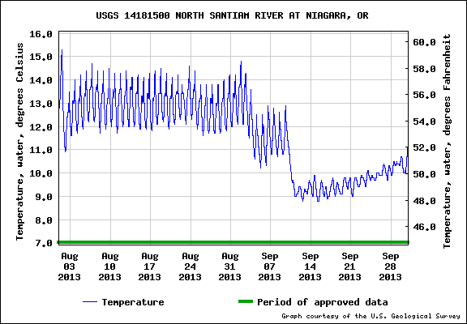**North Santiam Temperatures and Minto Mortality:**

2013 mortality—males-32, females 54=86 total

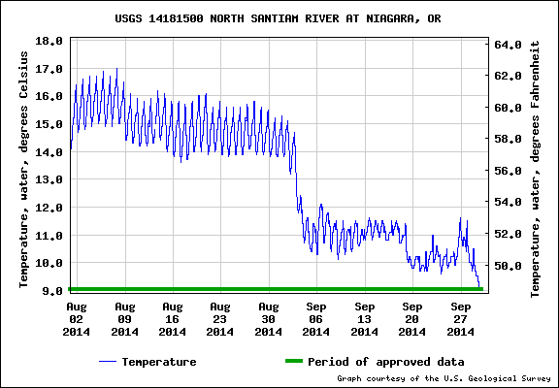

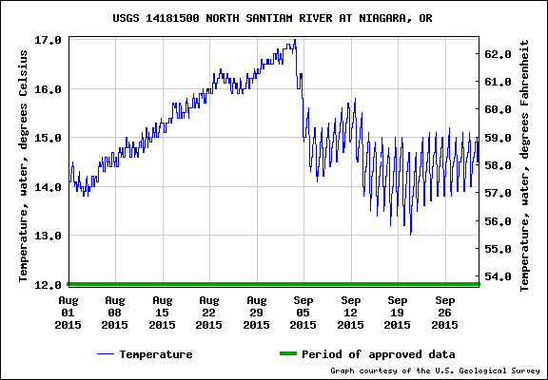2014 mortality—males-32, females 83=115 total

2015 mortality—males-61, females-226=287 total